# Phạm Quang Hưng – HE160005 – SWE201c

**Question 1**

Firstly, considering the **requirement’s characteristics**:

* Reliability: the requirements are comprehensive and this project is possible to implement
* Types and number of requirements: there are 6 requirements (4 functional requirements for customers’ role and 2 non-functional for the system (will list below). What’s more, those requirements are not ambiguous.
* How often the requirements can change: in this context, the requirements are unlikely to change because the functional requirements are clearly defined in the project description (app’s compatibility in different browsers, expected features in mobile version,…). On top of that, the IT support of MamaSpa can act as reliable facilitators in case there are some missing requirements
* Can the requirements be defined at an early stage: as I explained above, the requirements are given in great details and easy to understand. Should any requirements are missing, we still reach IT support for further help so it’s not a big deal.

Secondly, let’s have a look **into development team:**

* Team size: the project description doesn’t provide exact number of team member.
* How well the dev team understands user requirements: they may have a good understanding since they have encountered these kinds of project and situations before.

Thirdly, in terms of **user involvement** in the project, I think users play a crucial role since the project itself is user-centered. In order to bring the best experience to the customers, MaMaSpa should include them in the project to evaluate features, UI/UX before giving the project to the General Availability (GA) stage.

To conclude, I personally think that **Agile method** would satisfies the characteristics and requirements listed above. This method has an advantage is that it’s the combination of the incremental and iterative approach, which mean the project would be built by each feature in a small portion, then gradually adding features and increasing their completeness. By doing that, users can easily be involved in each iteration and see what’s done and what should be improve. Additionally, this is an average-scale project with not so big team size so Agile is suitable for more flexibility and dynamic.

**Question 2**

**4 functional requirements of customers**:

* Customers must identify themselves using their registered accounts or other authentication methods (e.g biometric).
* Customers can make an appointment through given steps (selection => payment => confirmation).
* Customers can access MaMaSpa services though mobile device (Android and iOS).
* Customers can view all services of spa.

**2 non-functional requirements of system:**

* The system shall be merged into one web application with sufficient features.
* Additional features should be included to support customer such as online booking, membership management, SMS and text reminders,…

**Question 3**

* As a customer, I want to view all services of the spa so that I can easily choose what suite me the most and see what type of service is the best most wanted.
* As a customer, I want to receive notification before official appointment so that I can manage my time and have a proper preparation to enjoy the service at MamaSpa.

**Question 4**

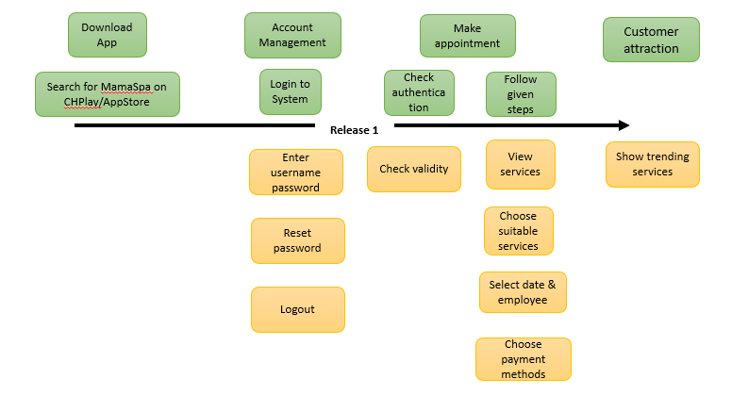 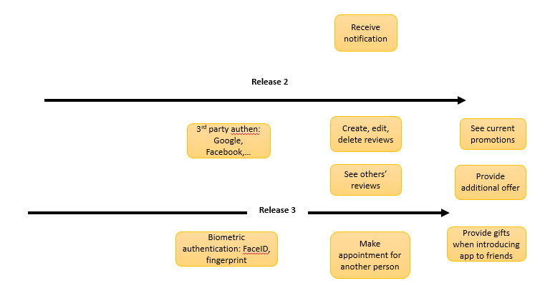

**Question 5**

1. I agree with this order. To support my point of views, I would want to bring out the following reasons:

* This is the medium-sized projects, with possible requirement changes or future upgrade as the customer is closely involved during each phase.
* Following the incremental delivery principle of Agile, the app should be developed in increments with the customers specifying the additional requirements to be included in each increment.
* As the app is closely related to customers, it should expect requirements to change and design the system to better accommodate these changes.
* The overall structure of the project is not complicated. Principle requirements as well as feature are comprehensive and user-centered so focusing on simplicity of the software bring various advantages and reduce unnecessary risks and time-consuming problems.

1. I suggest the team to use black-box testing because there would be user’s involvement to evaluate the advantages/drawbacks of the project, especially the usability of the system quality (how well the system adapts to user needs, how easy it is to learn the features the system)